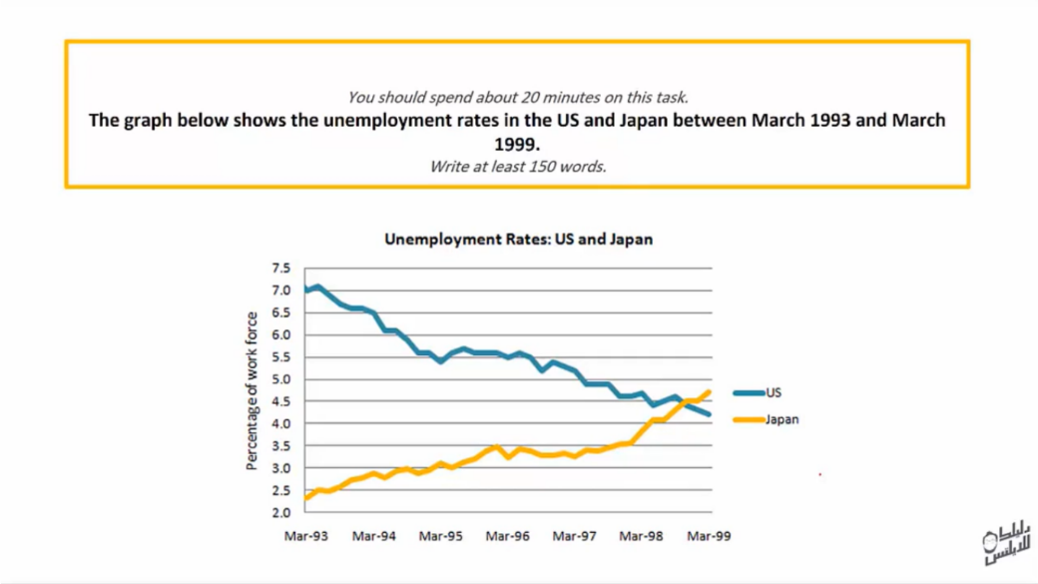

**This line charts depicts the percentage of unemployment in two countries USA and Japan from March 1993 to March 1999. It is clear from the graph that ratio of population they do not work in United State and Japan ware fluctuated.**

**According to what is shown that figure of work force in United State drop slightly from 7% to 5.6%, but between 1995 and 1996 the per cent was fluctuated. In the last three years the ratio was sink nearly by 4%. On the other hand, Japan chart illustrate the proportion of work force climbed gradually from 2% to 3.5%. After that in March 1996 the percentage dip then it was increase modestly to peak 4.5%.**

**To sum up we could say that proportion of United state of unemployment had soar sharply while the number in the other country was decrease.**

**ANSWER**

**This line charts depicts the percentage of unemployment in two countries USA and Japan from March 1993 to March 1999. It is clear from the graph that ratio of population they do not work in United State and Japan ware fluctuated.**

**According to what is shown that figure of work force in United State drop slightly from 7% to 5.6% , but between 1995 and 1996 the per cent was fluctuated. In the last three years the ratio ~~was~~ sink nearly by 4%. On the other hand, Japan chart illustrate the proportion of work force climbed gradually from 2% to 3.5% . After that in March 1996 the percentage dip then it was increase modestly to peak 4.5%.**

**To sum up we could say that proportion of United state of unemployment had soar sharply while the number in the other country was decrease.**